**SOFTWARE**

**REQUIREMENTS**

**SPECIFICATION**

**For**

**ONLINE SURVEY SYSTEM**

**Prepared by:-**

KAVIN SHANKAR D S

NARESH RAJA M L

AKSHAYAA S

## 1. Introduction

### 1.1 Purpose

Online surveys are widely used by organizations to collect data from their target audience. They offer several advantages over traditional paper-based surveys, including cost-effectiveness, efficiency, reach, and data accuracy. Online surveys can be used for various purposes, such as market research, employee feedback, academic research, customer satisfaction surveys, and opinion polls. They provide organizations with valuable insights into customer preferences, employee opinions, and public sentiment. Online surveys can be customized to target specific demographics or interests, allowing for tailored questions and response options. Additionally, they offer real-time data collection, enabling organizations to monitor responses and make adjustments as needed. In summary, online surveys are a powerful tool for organizations to gather information, improve decision-making, and enhance their operations.

### 1.2 Document Conventions

* Convention for Main title

Font face: Times New Roman



Font style: Bold

Font Size: 14

* Convention for Sub title

Font face: Times New Roman



Font style: Bold

Font Size: 12

* Convention for body

Font face: Times New Roman



Font Size: 12

### 1.3 Scope of Development Project

An online survey system encompasses a wide range of features designed to facilitate efficient and comprehensive data collection. Its scope includes user-friendly survey creation tools supporting diverse question types and customization options. The system enables distribution through various channels such as email and social media, with integrated participant management tools ensuring secure and organized data collection. Features like anonymous responses, multi-language support, and survey logic enhance flexibility and inclusivity. Robust data analysis and reporting tools, coupled with export options and integration capabilities, empower users to derive meaningful insights. Ensuring security and privacy through encryption and compliance with regulations is integral. The system should be scalable to handle large participant numbers, with real-time monitoring, notifications, and mobile responsiveness for an optimal user experience. Templates, user authentication, and feedback mechanisms contribute to versatility and user engagement. Additionally, survey reminders and accessibility considerations further enhance the overall functionality of the online survey system, catering to the specific needs and preferences of diverse survey projects.

### 1.4 Definitions, Acronyms and Abbreviations

JAVA -> platform independence

SQL-> Structured query Language

ER-> Entity Relationship

UML -> Unified Modeling Language

IDE-> Integrated Development Environment

SRS-> Software Requirement Specification

### 1.5 References:

### Books

* Web Survey Systems: A Primer & Buying Guide by Mario Giorno
* Conducting Online Surveys By Valerie M. Sue, Lois A. Ritter
* Handbook of Research on Electronic Surveys and Measurements By Rodney A. Reynolds, Robert Woods
* **website**



https://www.surveysystem.com/online-survey-software.htm

https://www.surveymonkey.com/

## 2. Overall Descriptions

### 2.1 Product Perspective

Use Case of online survey system

The product perspective of an online survey system involves prioritizing user-centric design, adaptability, and customization. Ensuring cross-device compatibility, scalability, and real-time feedback mechanisms enhances user experience and project flexibility. Robust security measures and compliance with regulations are crucial for protecting participant data. Incorporating advanced analytics tools and providing comprehensive customer support contribute to the system's effectiveness. Additionally, considering cost-effectiveness and planning for future innovation ensures the online survey system remains competitive and relevant in the evolving landscape.

### 2.2 Product Function

Entity Relationship Diagram of online survey system

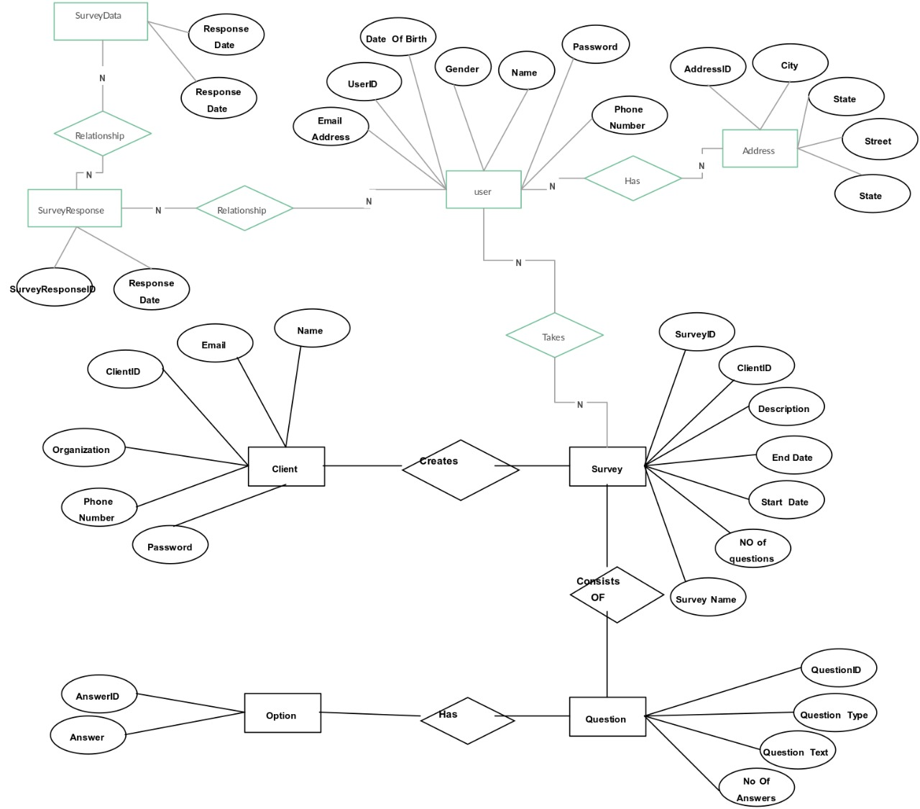

The online survey system offers a user-centric interface for creating diverse surveys with adaptable and customizable features. It ensures cross-device compatibility, scalability, and real-time feedback. Robust security measures protect participant data, and compliance with regulations is prioritized. The system integrates seamlessly with other tools and systems, providing advanced analytics for actionable insights. Comprehensive customer support and training resources empower users. Cost-effectiveness is considered through flexible pricing models. Continuous updates and innovation anticipate evolving trends, ensuring the system remains competitive and relevant, delivering efficient and effective functionality for survey creation, distribution, and analysis in various industries.

### 2.3 User Classes and Characteristics

**Survey Creators**:

Characteristics: Typically researchers, administrators, or project managers responsible for designing and managing surveys.

Needs:

* User-friendly survey creation tools.
* Customization options for question types, survey appearance, and logic.
* Access to data analysis features to derive insights from survey results.
* Dashboard for monitoring survey progress and participant engagement.
* Tools for managing participate lists and controlling survey access.

**Survey Participants:**

Characteristics: General users invited to participate in surveys, representing the target audience for data collection.

Needs:

* Intuitive and easy-to-navigate survey interfaces.
* Clear instructions and guidance for completing the survey.
* Mobile-responsive design for accessibility on various devices.
* Assurance of data privacy and security.
* A seamless and engaging survey-taking experience to encourage participation.

These two user classes represent the primary stakeholders in the online survey system—those who create and manage surveys and those who participate in them. By addressing the specific characteristics and needs of both groups, the online survey system can achieve a balance between advanced functionality for administrators and a user-friendly experience for participants, ultimately enhancing the effectiveness of the survey process.

### 2.4 Operating Environment

The product will be operating in windows environment. The Library Management System is a website and shall operate in all famous browsers, for a model we are taking Microsoft Internet Explorer,Google Chrome,and Mozilla Firefox.Also it will be compatible with the IE 6.0. Most of the features will be compatible with the Mozilla Firefox & Opera 7.0 or higher version. The only requirement to use this online product would be the internet connection. The hardware configuration include Hard Disk: 40 GB, Monitor: 15” Color monitor, Keyboard: 122 keys. The basic input devices required are keyboard, mouse and output devices are monitor, printer etc.

### 2.5 Assumptions and Dependencies

Assumptions:

* Participants will engage actively and provide honest responses.
* The target audience has reliable internet access.
* Users possess a basic understanding of online survey platforms.
* Participants will provide accurate and truthful information.
* Implemented security measures effectively safeguard participant data.
* The system is compatible with various devices and browsers.
* Participants will allocate sufficient time for thoughtful survey completion.
* Underlying technologies and infrastructure will remain stable.
* Survey creators are familiar with tools, requiring minimal training.
* The system complies with data protection laws and regulations.

Dependencies:

* Database availability and performance.
* Reliability of Internet Service Providers (ISPs).
* Functionality of external APIs or integrated services.
* Browser adherence to standards for consistent rendering.
* Timely updates and support from the survey tool provider.
* Participant consent for survey participation.
* Reliability of payment gateways for monetary transactions.
* Stability and scalability of server infrastructure.
* Obtaining necessary approvals from regulatory bodies.
* Timely feedback from participants for survey adjustments.

### 2.6 Requirement

Software Configuration:-

This software package is developed using java as front end which is supported by sun micro system. Microsoft SQL Server as the back end to store the database. Operating System: Windows NT, windows 98, Windows XP

Language: Java Runtime Environment, eclipse (front end)

Database: MS SQL Server (back end)

### 2.7 Data Requirement

An online survey system requires comprehensive data elements, including survey metadata, participant and question data, response records, configuration settings, and user account information. Access control data, system logs, and security information are crucial for managing user roles and ensuring data protection. Additionally, logs tracking survey participation, distribution details, and metadata for analysis contribute to effective survey management. Integration data and feedback records enhance the system's functionality. Careful consideration of data privacy and compliance with regulations is essential for maintaining the integrity and security of the information collected throughout the survey process.

## 3. External Interface Requirement

### 3.1 GUI

* User-friendly Interface: Design an intuitive and easy-to-navigate graphical user interface (GUI) for both survey creators and participants, promoting a positive user experience.
* Dashboard Overview: Include a comprehensive dashboard that provides a quick summary of key survey activities, such as creation, distribution, and analysis, enhancing user efficiency.
* Survey Creation Tools: Offer a streamlined interface for survey creators to design surveys effortlessly, incorporating various question types, layout options, and logic features.
* Participant Interface: Create a clear and responsive interface for participants to navigate surveys easily, including progress indicators and straightforward instructions.
* Data Analysis Features: Implement analytical tools within the GUI, enabling survey creators to interpret response data visually through charts, graphs, and downloadable reports.
* Multilingual Support: Ensure the GUI supports multiple languages, allowing users to work in their preferred language, enhancing accessibility for diverse user bases.
* Notification System: Integrate a notification centre within the GUI to alert users about new survey responses, participant activities, or system updates in a timely and organized manner.

Login Interface:-

In case the user is not yet registered, he can enter the details and register to create his account. Once his account is created he can ‘Login’ which asks the user to type his username and password. If the user entered either his username or password incorrectly then an error message appears.

## 4. System Features

The users of the system should be provided the surety that their account is secure. This is possible by providing:-

* Intuitive Survey Creation: A user-friendly interface for easy customization of surveys, offering various question types and logic features.
* Real-Time Monitoring: Continuous tracking of survey progress, participant engagement, and response rates for instant insights.
* Comprehensive Data Analysis: Robust analytical tools for interpreting and visualizing response data through charts, graphs, and downloadable reports.
* Participant Management Tools: Efficient features for managing participant lists, sending invitations, and monitoring participant activities, ensuring a smooth survey distribution process.

## 5. Other Non-functional Requirements

### 5.1 Performance Requirement

Performance requirements for an online survey system focus on ensuring efficient and responsive functionality under various conditions. Here are key performance requirements:

* + Ensure low-latency responses for survey creation and participant actions.
  + Implement horizontal scalability to accommodate growing user and survey numbers.
  + Prioritize efficient data processing, fast survey loading, and overall system reliability through measures like caching and database optimization.

### 5.2 Safety Requirement

The database may get crashed at any certain time due to virus or operating system failure. Therefore, it is required to take the database backup so that the database is not lost. Proper UPS/inverter facility should be there in case of power supply failure.

### 5.3 Security Requirement

* Implement end-to-end encryption for secure data transmission.
* Enforce strict access controls with role-based permissions.
* Utilize strong and multifactor authentication mechanisms.
* Enforce secure password policies for user account protection.
* Implement comprehensive audit logging for activity tracking.
* Conduct regular security audits and vulnerability assessments.
* Adhere to data protection regulations and ensure privacy compliance.

### 5.4 Requirement attributes

* Ensure clarity in requirements for accurate understanding.
* Complete specifications, leaving no gaps or ambiguities.
* Maintain consistency among requirements to avoid conflicts.
* Establish traceability links for easy monitoring and comprehension.
* Emphasize testability with verifiable criteria for each requirement.
* Verify feasibility considering technological and budget constraints.
* Prioritize requirements based on their significance for effective resource allocation.

### 5.5 Business Rules

A business rule is anything that captures and implements business policies and practices. A rule can enforce business policy, make a decision, or infer new data from existing data. This includes the rules and regulations that the System users should abide by. This includes the cost of the project and the discount offers provided. The users should avoid illegal rules and protocols. Neither admin nor member should cross the rules and regulations.

### 5.6 User Requirement

User requirements, often known as user needs or functional requirements, outline the features and functionalities that users expect from a system or product. These specifications are derived from the perspectives and expectations of end-users and stakeholders. User requirements typically encompass the desired behaviours, capabilities, and constraints of the system, focusing on what the user needs to achieve. These requirements serve as a foundation for the design and development process, ensuring that the final product aligns with user expectations and provides a satisfactory user experience. User requirements are essential for building systems that meet the intended purpose and deliver value to the end-users.

.

The admin provides certain facilities to the users in the form of:- ➢ Backup and Recovery

* Forgot Password
* Data migration i.e. whenever user registers for the first time then the data is stored in the server
* Data replication i.e. if the data is lost in one branch, it is still stored with the server
* Auto Recovery i.e. frequently auto saving the information
* Maintaining files i.e. File Organization
* The server must be maintained regularly and it has to be updated from time to time

## 6. Other Requirements

### 6.1 Data and Category Requirement

Data and category requirements define the types of information collected and how it is organized within a system. This includes specifying data formats, categories, and classifications for effective management. In an online survey system, data requirements may detail participant demographics, survey questions, and response data. Categories could include themes or topics for organizing surveys. Clear definitions, validation rules, and relationships between different data elements ensure accurate and meaningful information. These requirements are crucial for designing databases, ensuring data integrity, and facilitating efficient analysis, contributing to a well-structured and effective online survey system that meets user needs and business objectives.

### 6.2 Appendix

A: Admin, Abbreviation, Acronym, Assumptions; B: Business rules; C: Creator, Class, Client, Conventions; D: Data requirement, Dependencies; G: GUI; K: Key; M: Member; N: Non-functional Requirement; O: Operating environment; P:

Participant, Performance, Perspective, Purpose; R: Requirement, Requirement attributes; S: Survey, Safety, Scope, Security, System features; U: User, User class and characteristics, User requirement;

### 6.3 Glossary

The following are the list of conventions and acronyms used in this document and the project as well:

* Administrator: A login id representing a user with user administration privileges to the software
* User: A general login id assigned to most users
* Client: Intended users for the software
* SQL: Structured Query Language; used to retrieve information from a database
* SQL Server: A server used to store data in an organized format
* Layer: Represents a section of the project
* User Interface Layer: The section of the assignment referring to what the user interacts with directly
* Application Logic Layer: The section of the assignment referring to the Web Server. This is where all computations are completed
* Data Storage Layer: The section of the assignment referring to where all data is record
* Use Case: A broad level diagram of the project showing a basic overview
* Class diagram: It is a type of static structure diagram that describes the structure of a system by showing the system’s cases, their attributes, and the relationships between the classes
* Interface: Something used to communicate across different mediums
* Unique Key: Used to differentiate entries in a database

### 6.4 Class Diagram

. 